CSC 212 -Data Structures

Name: ____________________

Sorting and BT traversal in-class exercises

Exercise 1

Suppose you have the following list of numbers to sort: [19, 1, 9, 7, 3, 10, 13, 15, 8, 12] which list represents the partially sorted list after three complete passes of bubble sort?

1. [1,9,19,7,3,10,13,15,8,12]

2. [1,3,7,9,10,8,12,13,15,19]

3. [1,7,3,9,10,13,8,12,15,19]

4. [1,9,19,7,3,10,13,15,8,12

Exercise 2

Given the following list of numbers: [21, 1, 26, 45, 29, 28, 2, 9, 16, 49, 39, 27, 43, 34, 46, 40], illustrate how the list will be sorted using mergesort?

Exercise 3

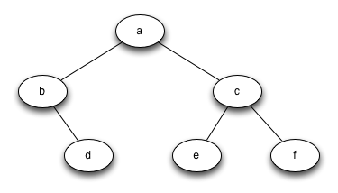

1. Show the output of the preorder traversal of the above tree
2. Show the output of the inorder traversal of the above tree
3. Show the output of the postorder traversal of the above tree